Scuba Diving- Starting out commitments 2025 and Dive Kit Guide

1. £££s? How expensive is diving as a sport?
Cold water scuba is no more expensive in terms of kit than most other outdoor sports. Training in a club represents a huge saving over learning to dive with commercial schools where the training costs alone add up to several hundred £s just for a basic qualification.
Initial outlay for training (mask, fins, pool boots, snorkel) ca £150
There is one more expensive item that is essential to allow you to progress from the pool to the sea and that is a dry suit. As your last one or two pool sessions will use the dry suit. The club does not have dry.suits to loan. Depending on your measurements, sometimes club members can lend personal spare suits out to trainees in the pool, but while this might allow you to complete pool training, we recommend you plan to purchase the dry suit for February/March (assuming you start pool training in November). For a new dry suit budget £800-1200. For decent 2nd hand you might find something for £300-£500.
See further on for advice on what to get and where to get it…

The rest of your kit you can acquire gradually over your first year or two of open water diving. The club provides trainees BCD, cylinders, weights, regulators free of charge. Once qualified, these continue to be available though priority goes to trainees.This gives you time to gradually accumulate your own kit. During your first year your first purchase might be a computer (£200ish), and after that probably your own weight belt and weights (£50).
Into your second year and we’d expect you to be looking at gradually getting the rest of your kit to become independent of club kit.

2. Time commitment

Unlike some other sports, especially during your training period when you are learning many new skills, continuity and reasonably regular diving are important.

Pool

2h Tuesday evenings over a pool season of 10 weeks and a few other evenings for lectures. We only use the pool for a short season, so if you miss more than a few sessions you might not be able to progress.

Sunday Sea Diving

Open Water training (in the Sea) normally would be from March/April, though if you progress more quickly through pool drills you might be able to get into the sea sooner. The club organises dives every Sunday, sea conditions permitting. While you don’t need to dive every available Sunday, for progress in your training you really need to be able to get out reasonably regularly. We will plan for one Sunday a month to be a dedicated training day. Early in the season you can expect to be away from early morning to mid-afternoon, and as the days get longer Sunday dive days become full day outings. We usually dive on the Buchan Coast, and also around Stonehaven.

Weekend and longer trips

Weekend dive trips offer an opportunity to explore further afield. We run several a year that are only open to divers who have completed training, but there are 2 that are recommended to new divers. These are

Oban Area Training Weekend in March: Dates tbc but will likely be one of the last 2 weekends in March.

North Coast (Bettyhill) Long Weekend: Usually July dates tbc.

We also run an annual Burns Supper Dive Weekend (Ratagan). Depending on the dates it may be possible for new pool season divers to get their first sea dives, but all are welcome to come for the craic.

Starting Dive Kit Guide for New Divers

Where to buy your kit: (Before any major purchase, have a chat with the experienced divers at the Pool or on a Sunday….)

1. Local Dive Shop:

In Aberdeen we know longer have a local dive shop (but we do have local businesses that will do air fills and kit servicing). If you travel regularly to the central belt, there are stores in Dundee, Glasgow and Edinburgh.

2.Online dive stores

If you know what you want, and particularly if it is not something you need to try out for size, there are plenty of online stores that offer good discounts. If you are not sure contact one of the club training instructors for advice- feel free to send a web link for something you are thinking about getting. Those to check include Mikes Divestore, Simply Scuba, Diving Direct, Kent Diving, Scubastore.

3. 2nd Hand. Local ads, eBay and Gumtree

There are occasions when 2nd hand kit becomes available on Gumtree or elsewhere. There are also occasional ads on the Club spond forum or on the Scotsac web site, and there is also a Facebook Group “DIVING STUFF FOR SALE – SCOTLAND” . On eBay you can get a huge range of dive kit but beware; in recent years auctions have been bid up to prices that are almost the same (or even higher) as those for buying the same kit new- so you need to do your homework and take advice. Also, some kit (regulators for example) may look good value second hand, but may no longer be quite so good value after you factor in getting it professionally serviced (essential for regulators).

If you want advice on 2nd hand kit, ask at a pool or pub session, or email us the link to the advert for comment.

What do you need to get? (new divers)

1 Fins, Mask and Snorkel
While on your first one or two pool sessions you could use club stuff you should plan to get your own fins, mask and snorkel at least by your 3rd session.

Fins: As you’ll be using a dry suit with boots you’ll need to get open heel style fins. There are used in the pool in combination with rubber (neoprene) pool shoes/boots. If you find a pair of boots in the club boxes at the pool these may see you through the pool training but if not buy a pair of pool boots, they’ll come in handy when you go to warm water diving (the trouble with relying on size dependent equipment in the club boxes at the pool is that one week you might find what you need and another week you might not. There are a plethora of different models of fins available, and there are all sorts of claims about different performance. However, an unscientific survey of club divers in Scotland will show “Mares Avanti Quattro Plus” to be the most popular starting fins and you can’t go wrong with them.

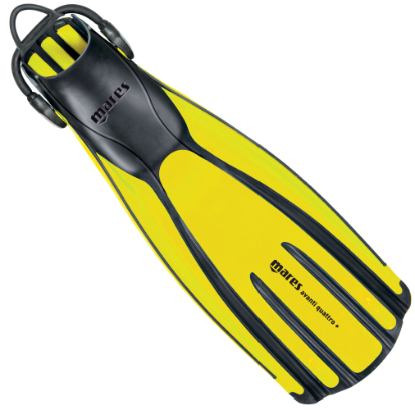 | 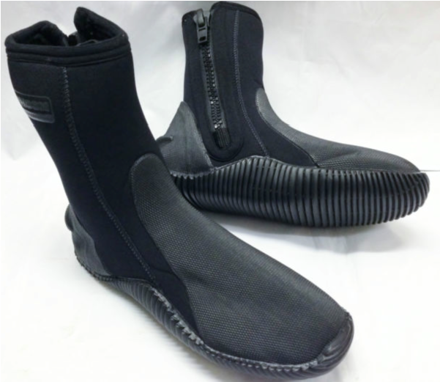

They are sized to different boot size and so you do need to check this out carefully if ordering online.
Boots: The fins we use are open heel, designed for your drysuit boots to fit inside. So, for the swimming pool training we use these fins with pool/watersports boots/bootees, like those you’d wear to go windsurfing or dinghy sailing. There may be a pair that fit you perfectly in the club kit
boxes at our pool sessions but you may need to buy these- outdoor/watersports stores sell these but they are also easily found at amazon and other online traders. Make sure you get the style with the small ridge at the back of the ankle that acts to retain your fin strap.

Keep them after you finish with the pool sessions and you’ll be able to use them in warm water diving with your open heel fins.

2. Mask and Snorkel:

These are essential. The mask does need to fit and at your pool session ask your instructor on how to check this. As for snorkels, get the simplest and cheapest. Sometimes the economy mask and snorkel sets at discount sports shops or supermarkets work out as excellent starting kit.

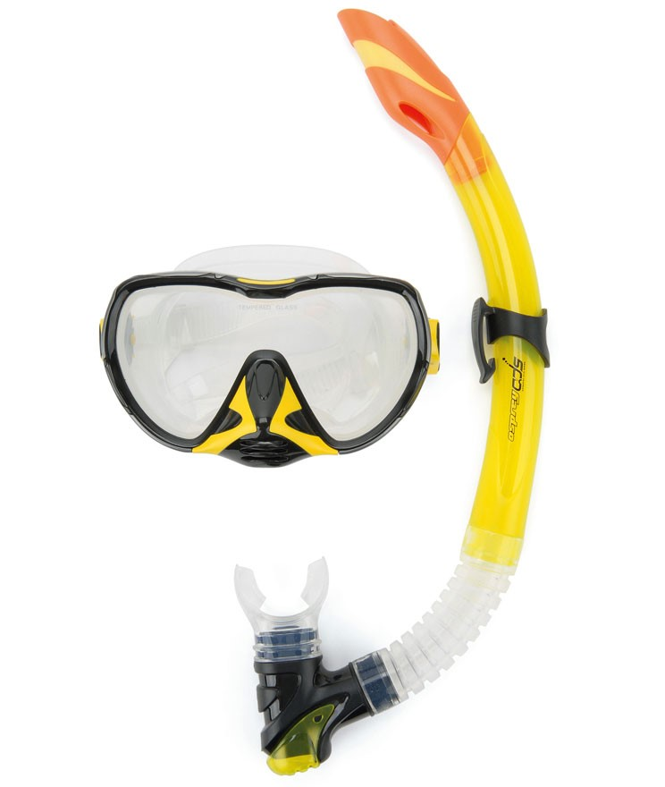
Visual Problems and Diving: Astigmatism, Short Sight, Long Sight

You cannot wear spectacles under a dive mask. Neither should you wear contact lenses- if you flood the mask you’ll lose your lenses. Depending on the degree to which your sight is impaired you may need a prescription mask. This is a standard dive mask where the lenses are swapped out for corrective lenses based on your optician’s prescription. Prescription masks cost 2-3x more than standard masks so get advice from club members before taking this step. If you are just long-sighted you might get by with either big gauges/displays, or standard masks with little magnifying inserts attached.

3. Gloves and Hood

Hoods sometimes come bundled with dry suits but otherwise go for a 5mm neoprene hood. Gloves are typically either 5mm or 3mm neoprene. Tolerance of cold water varies between individuals- so for example some divers wear no gloves at all, or maybe just 3mm, while others prefer 5mm. The thicker gloves obviously incur a loss of dexterity, and some prefer 1 or 2 finger mitts. Our advice is to start with 5mm gloves.

4. Drysuit

Buying your first dry suit can be a daunting business; it is expensive, there are many options to choose from, and because divers are opinionated lot, you may get conflicting advice on what is best. However, that’s no different from buying other sports equipment (anything from a mountain bike to a set of golf clubs).
The info below is a general guide but we strongly advise you to come and talk to one of the experienced divers in the club, either at the pool or in the pub, before “taking the plunge” and ordering. A well-chosen drysuit will last you for years.
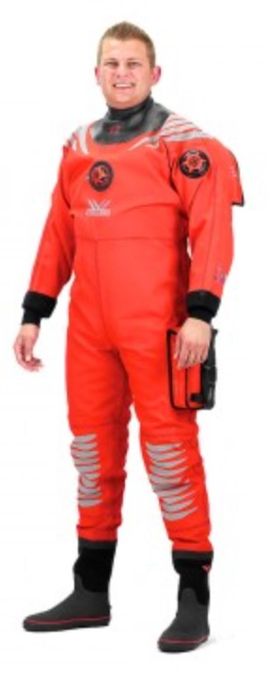 | 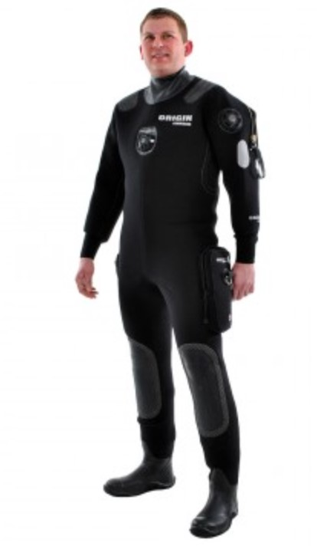
Membrane suit | Compressed neoprene suit

What is a drysuit?

Basically it’s a whole body suit with boots that is made of waterproof material and has seals at the neck and wrists to stop any water getting in. There also has to be some form of zip entry using a waterproof zip, (which in fact were a spin-off from the Apollo space programme in the 1960s).

Materials

Suit fabric

Dry suit fabrics fall into 2 categories: membrane or compressed neoprene. Membrane suits are built from a 3 layer (sometimes known as trilaminate) fabric with an outer thin woven cordura like layer to provide abrasion resistance, a middle waterproof membrane and a rubberized internal layer. Membrane suits have minimal insulating properties ie they keep you dry but not warm. Because of this they are always worn with an insulating undersuit which is basically a one-piece jumpsuit made either out of fleece material or filled with synthetic down like a sleeping bag.

Neoprene suits are made from neoprene rubber. The garment is made waterproof by sealing the seams with waterproof tape. To get adequate insulation in cold water neoprene rubber would need to be up to 8mm thick and that gives all sorts of problems for divers due to its compressibility affecting buoyancy. So, for dry suits, neoprene is put through a compression process to reduce its thickness to a few mm. This means you get more insulation for less thickness and weight and no buoyancy problems. There are different degrees of compression, and the most extreme (and expensive) compression process gives a material only about 1.5mm thick known as crushed neoprene. Neoprene suits require lighter undergarments than membrane drysuits.

Which is best- membrane or compressed neoprene? Well that really depends on who you ask as both have pros and cons. The innate insulation of neoprene suits and their easy repairability makes them attractive to commercial divers. On the other hand, they are more buoyant compared to membrane suits and require you to carry more lead weight (this is significant if your body build is already quite buoyant). Membrane suits require a warm undersuit, but at the same time are lighter, generally require you to carry less lead weight, and are more easily dried in the event of a flood.

90% of the divers in Grampian SAC use Membrane suits; that may be more a reflection of herd mentality than anything else, but it does mean that the advice we will give may be biased to membrane suits.

Suit Seals and Boots

- As well as the fabric of the dry suit, there are the seals and boots to consider. The seals at the neck and wrist must obviously stop the entry of water. When you first start dry suit diving, the effectiveness of these seals can seem something of a miracle. Seals are made from one of three materials
- Latex Seals: This is a supple stretchy substance that should firmly wrap round your wrists and neck. Latex seals come as either standard or heavy duty. The heavy-duty seals last a bit longer, but all latex seals perish and will need changing every few years. Once you know how to do it, this can be a DIY job, or alternatively can be done by most dive shops and there is a local dry suit repair business in Aberdeen. Latex neck seals when new will probably be too tight and it is necessary to use scissors cut away concentric rings of the material until the seal fits right. Ask for advice before you do this! One issue with latex seals, particularly the neck seal is a rash that is likely to be due to both rubbing of latex against the skin of the neck and a degree of contact allergy. It affects some divers, though usually the application of a barrier cream before diving will prevent this problem
- Neoprene seals. These last a lot longer but have the disadvantage that they can be leakier than latex. Avoid neoprene wrist seals if you have very slender wrists.
.

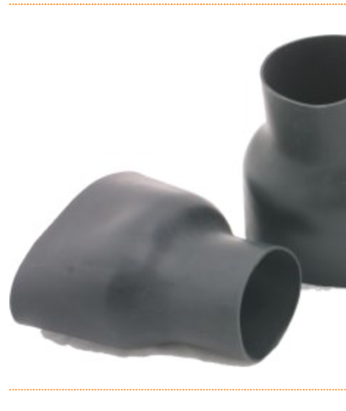 | 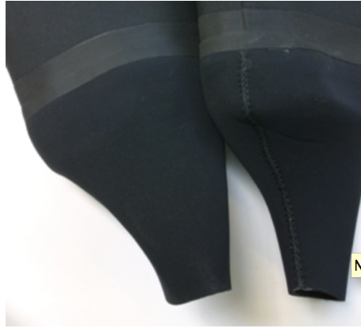 | 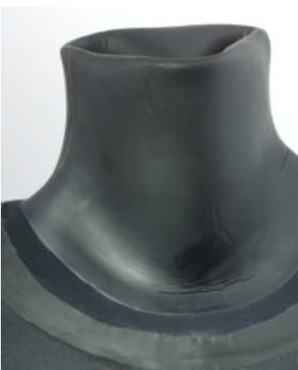 | 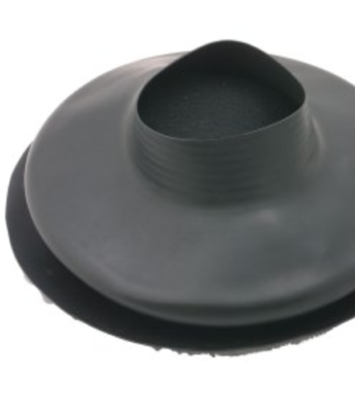
Latex cuff seals | Neoprene Cuffs | Neoprene Neck | Latex neck

- Silicone Seals: Offer the suppleness of latex, without risk of neck rash, and are held onto your suit using a clip mechanism rather than glue, which means they can be changed in minutes. Because the clip mechanism is built into the suit, the suit can be a bit more expensive, but the ease of changeover means that we see these increasingly fitted to new suits. Users of silicone seals (including the writer of this piece) find them superior in convenience, reliability and comfort and worth the marginal extra expense.
Boots normally are just glued and sealed onto the ends of the legs. They may come in heavy and light duty format. Heavy duty is good for shore dives where you clamber over rough ground, but eventually even with heavy duty boots the soles pack up and they need replacing, which can easily be carried out by dry suit repair technicians. Alternatively, some dry suits come with just sock like ends to the legs made from waterproof neoprene and these are worn inside lace up rock boots.

The Zip

Waterproof zips allow either rear entry or front entry. While the front entry suits can be donned and doffed with no help, the zips are longer and more expensive to replace. Rear entry zips need a helper to do up and undo but you always have a dive buddy with you so that is not a big deal; they are shorter, and less subject to the bending stresses that front entry zips have. Most zips have brass guide teeth; plastic zips are fitted by some manufacturers but reported reliability is not so good. Dry suit zips, if looked after carefully (especially avoiding tight kinks/bends and trapped undersuits) will last for 5 or more years before replacement is necessary.
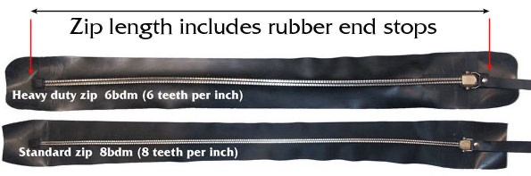

Pockets

One or two pockets are useful but not essential. If you have a choice get pockets on the outside of your thighs rather than the front, as they are less of an encumbrance when climbing back into our inflatables.

Buying a dry suit

New:
Off the peg or made to measure??

If you are buying new, once you have decided on the overall type
(membrane/compressed neoprene) your choice is between an off the peg suit in a dive shop or order made to measure. This choice turns partly on how close your own body is a fit for the standard sizes made by manufacturers. As an example, here is the Typhoon off the peg size chart
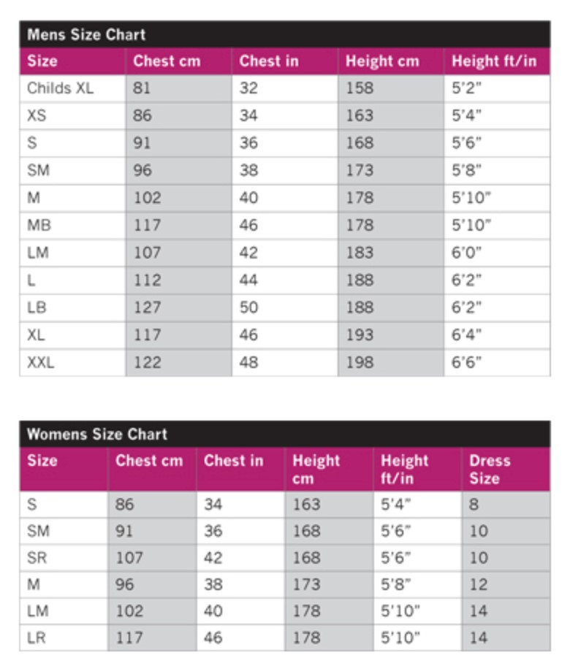

If you do go for off-the-peg, don’t just rely on the size chart…go to a dive shop and let them do the work for you even though it means a day trip to Dundee, Glasgow or Edinburgh.

If you want to get a perfect fit, made to measure is the route. This is not always that much more expensive than off the peg. Several members have had Seaskin Nova suits made (www.seaskin.co.uk) and are very satisfied with the results. For Seaskin you order via a web form where you are prompted to put in various measurements. You must do this with a helper to get them right. Even better, if your travels ever take you to West Yorkshire you can be measured at the factory. Slightly more “upmarket” are Otter – they take direct orders via the web site http://www.drysuits.co.uk, but may be cheaper to buy via one of their agents who can also help you do the measuring. As with Seaskin, you can get measured in the factory also. Ask in the club for advice on this. Some manufacturers insist you visit the factory or have a video call for fitting eg. O’Three who make high-end fitted crushed neoprene suits. If going down the made to measure route, lead times can be up to 12 weeks so bear this in mind when planning when to order.

Second Hand

The most important consideration is will you can try the dry suit for size, and leaks, before you hand over cash. During the club pool season you can test such suits in the swimming pool. Sometimes 2nd hand dry suits are sold by people who have given up diving and have had the suit sitting in the loft/cellar for months. There may be surprises with leaky zips, perished seals.. Diving a leaky suit in Scotland is cold and not a good experience.

Getting Help and Advice

Either at the pool or outside the pool season we meet on Tuesday evenings at the Inn at the Park. Usually one of us has a laptop or other internet device which means we can look at kit you might have questions about and advise you on purchase. Please do ask any of your Instructors or other club members for help and comment before spending any significant £s!.

Disclaimer

This information is given in good faith based on the personal experience of the author. It does not represent endorsement by the Scottish Sub-Aqua Club or any of its Branches.

